KARTA PRACY
Subject: FOOD – revision.

I. Fruit (F) or a vegetable (V)?

apricot, lime, pear, blackcurrant, aubergine, parsley, radish, cauliflower

II. Translate:

slice – _________________
stir – _________________
season – _________________
chop – _________________
peel – _________________
grate – _________________

III. ZADANIE MATURALNE
Put into the right order and fill in the gaps:

1. My favourite dish is Greek salad.
Then, slice/chop/cut .....................................
It’s very easy to make.
First, wash .....................................................
Next, mix .................................................
To prepare it, you need ...........................
Finally, season ................................. and
add/pour on ..........................................

IV. What does a continental/proper breakfast consist of?
CONTINENTAL: ..................................................................................................................................
PROPER: ...........................................................................................................................................

V. ZADANIE MATURALNE
Gościsz u siebie koleżankę/kolegę Anglii. Po śniadaniu wybieracie się na zwiedzanie miasta. Możesz wybrać z propozycji zamieszczonych na zdjęciach.
● Wybierz jedną opcję i uzasadnij swój wybór.
● Wyjaśnij, dlaczego odrzucasz pozostałe możliwości.
Picture 1 Picture 2 Picture 3

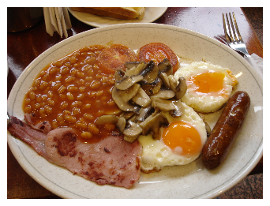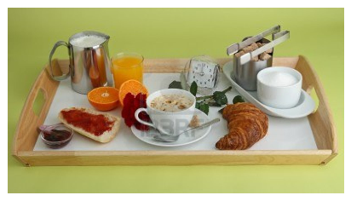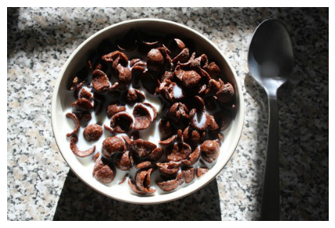
__________________________________________________________________________________________________________________________________________________________________________________________________________________________________________________________________________________________________________________________________________________________________________________________________________________________________________________________________________________________________________________________________________________________________________________________________________________________
______________________________________________________________________________________
VI. What do you call these dishes? Match!
grilled fish, prawn cocktail, apple pie, Greek salad, mussels, pork chop, roast beef, chicken soup,
steamed pudding, strawberries and cream, cheesecake, cabbage rolls
1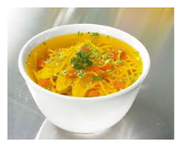2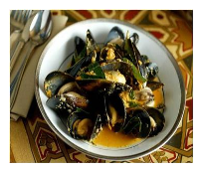3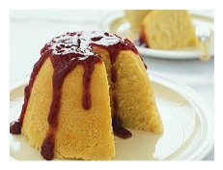4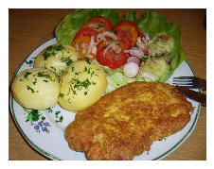5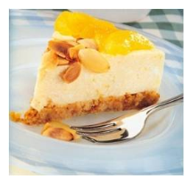6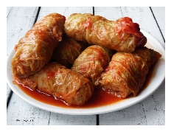7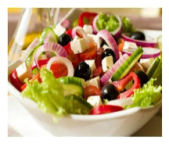8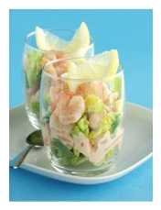9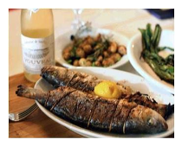10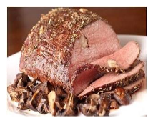11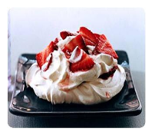12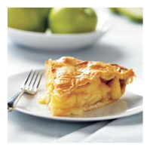

VII. Starters (S), main courses (M) or desserts (D)?
grilled fish, prawn cocktail, apple pie, Greek salad, mussels, pork chop, roast beef, chicken soup,
steamed pudding, strawberries and cream, cheesecake, cabbage rolls
VIII. ZADANIE MATURALNE
Tell us about your last visit to a restaurant.
(When and with whom, what did you have for a starter, main course and dessert, did you like it)
________________________________________________________________________________________________________________________________________________________________________________________________________________________________________________________________________________________________________________________________________________________________________________________________________________________________________________________________________________________________________________________________________________________________________________________________________________________________________________________________________________________________________________

IX. HOMEWORK: ZADANIE MATURALNE – STUDENT’S BOOK 3/103 (Repetytorium Pearson)

